DATA STRUCTURE AND ALGORITHMS

PBL-REPORT

**NED UNIVERSITY OF ENGINEERING & TECHNOLOGY**

Name: **Muhammad Taha**  
Roll.no: **EE-23319**  
Semester: **3rd**  
Sec: **D**

Contents

Acknowledgments 2

1. Introduction 3
2. Objectives 3
3. Problem Statement 3

Problem Solution Through Coding 4

Coding Approach 4

Once we recognized the difficulties highlighted in the problem statement, our team started a coding journey to find a useful solution. We decided to use PYTHON, PY GAME LIBRARY, SYS LIBRARY and OBJECT ORIENTED PROGRAM(OOP) as our main programming language because it's great for building dynamic and interactive module. PYTHON works well with web development and smoothly connects with databases, making it the perfect fit for our project 4

MODULE Development 4

Technical Implementation 4

7. Conclusion 8

# Acknowledgments

##### I would like to extend my sincere gratitude to Sir Ali Baig for his invaluable guidance, mentorship, and unwavering support throughout the development of this project. His expertise and encouragementhave been instrumental in the successful completion of the PBL.

##### Their commitment, teamwork, and individual contributions have significantly enriched the project, making it a collaborative success.

##### Thank you to Sir Ali Baig.

# Introduction

The IT world is changing fast, and to keep up, we need to keep learning and using what we learn. But sometimes, our busy schedules and where we live make it hard to apply what we've learned. That's where our project, called "PROJECT BASE LEARNING," comes in. It's like a helpful learning space that makes it easier toconnect what we learn in theory with real-life situations.

# Objectives

The primary objective of this program is to provide a hands-on experience with real-life projects. The focus is not merely on teaching concepts but on presenting real-life scenarios that empower participants to create applications using relevant tools. The PBL aims to:

* + Foster a step-by-step, laddered approach to learning.
  + Facilitate the development of larger, more robust applications.
  + Encourage the use of utilities in user-designed applications.
  + Promote unified coding for complete applications.
  + Guide learners in implementing concepts progressively.
  + Enhance skills and add practical value.
  + Provide exposure to real-life projects.
  + Create complex and useful applications through a mentor-supported, phased approach.

# Problem Statement

The problem statement for this project is to develop an interactive Bank Management System that allows users to create accounts, securely log in, and perform basic banking operations such as withdrawals and transfers through a graphical user interface (GUI). The system should ensure user-friendly interactions with features like animated buttons, real-time balance updates, and error handling. Additionally, it should manage customer data efficiently using object-oriented principles while providing a modular structure for easy scalability. However, the program currently lacks persistent data storage and advanced security measures, which are critical for a real-world banking application.

## Problem Solution Through Coding

### Coding Approach

Once we recognized the difficulties highlighted in the problem statement, our team started a coding journey to find a useful solution. We decided to use OOP as our main programming language because it's great for building dynamic and interactive websites. OOP works well with web development and smoothly connects with databases, making it the perfect fit for our project.

### Module Development

The OOP-based Bank Management System offers a GUI for account creation, login, withdrawals, and transfers with animated buttons and text inputs. The Bank Account class manages customer data, while modular functions keep the logic organized. Lacking data persistence, future upgrades could include database integration, encrypted PINs, and features like transaction history and loans. The module caters the user.

*Module Screenshots*

Main Page:

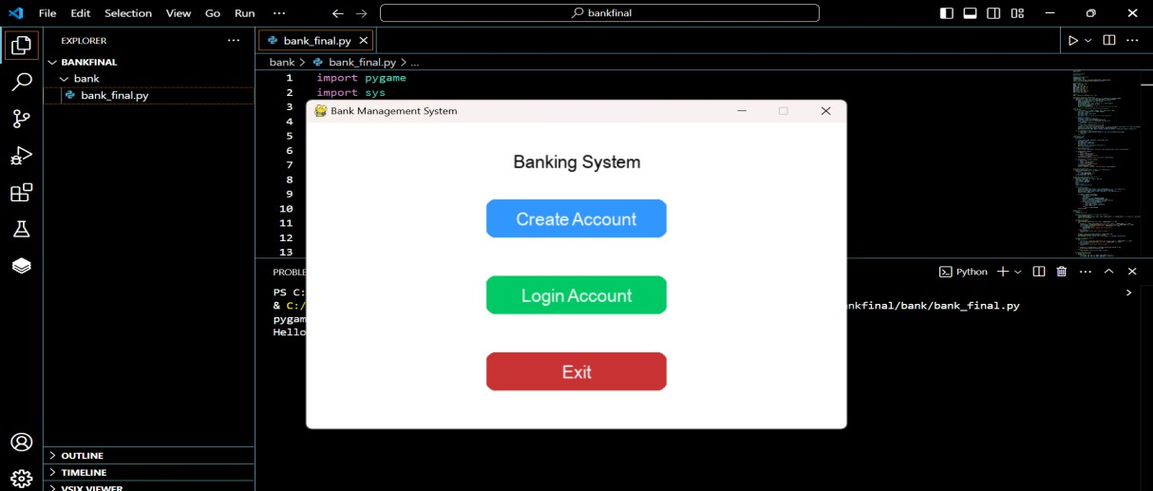

Account Creating Page & Withdraw:

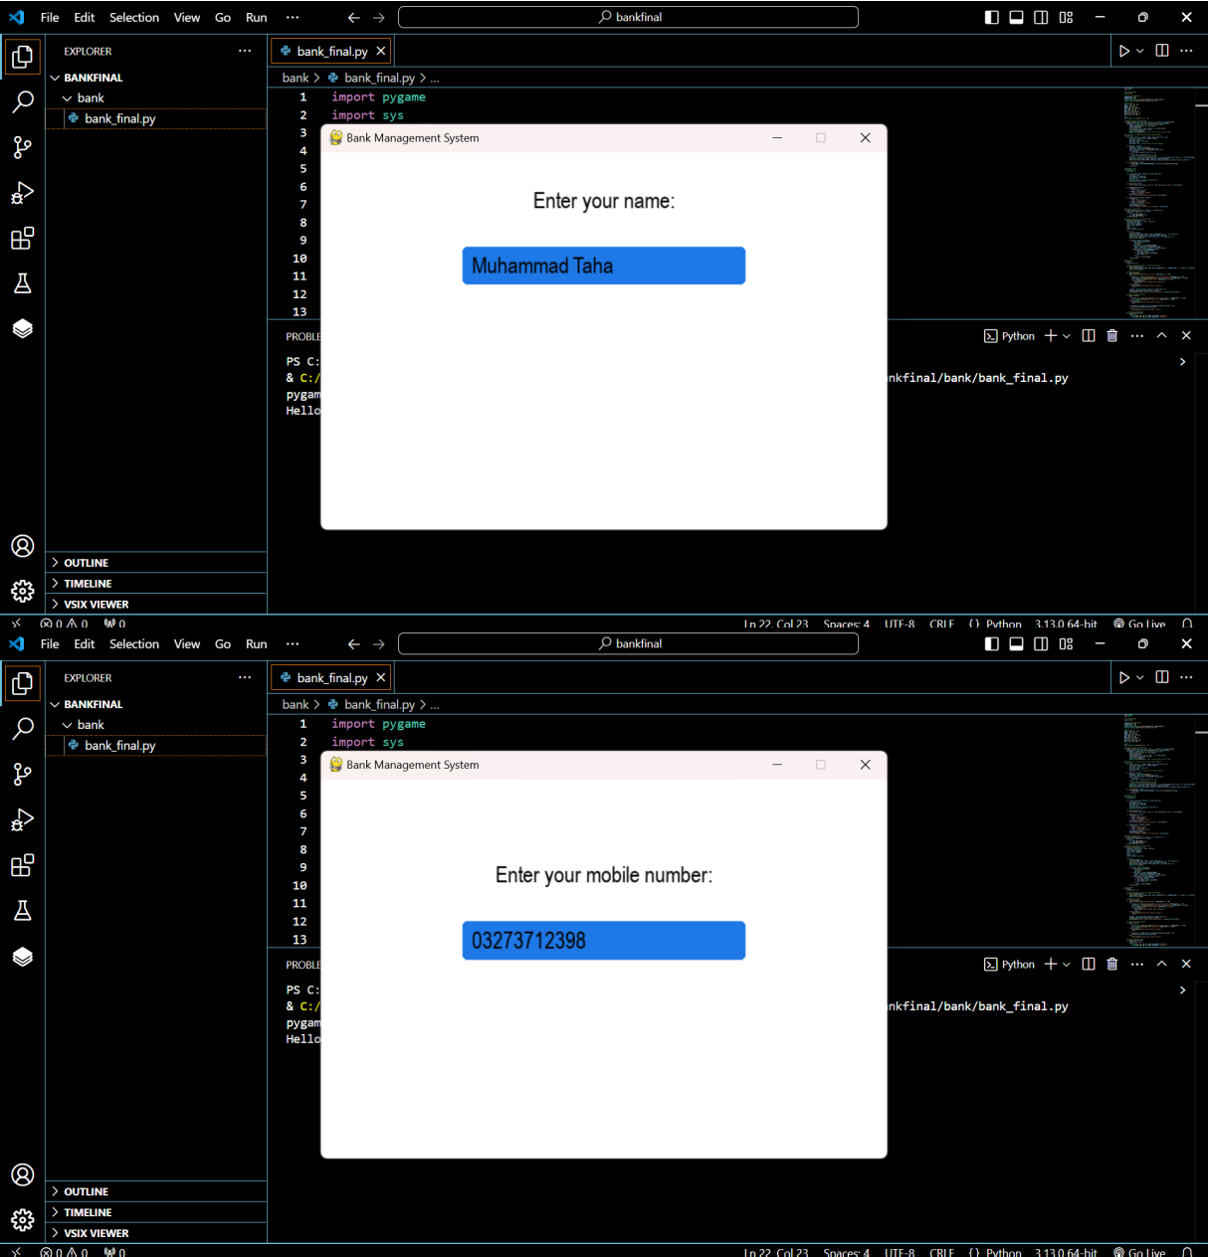

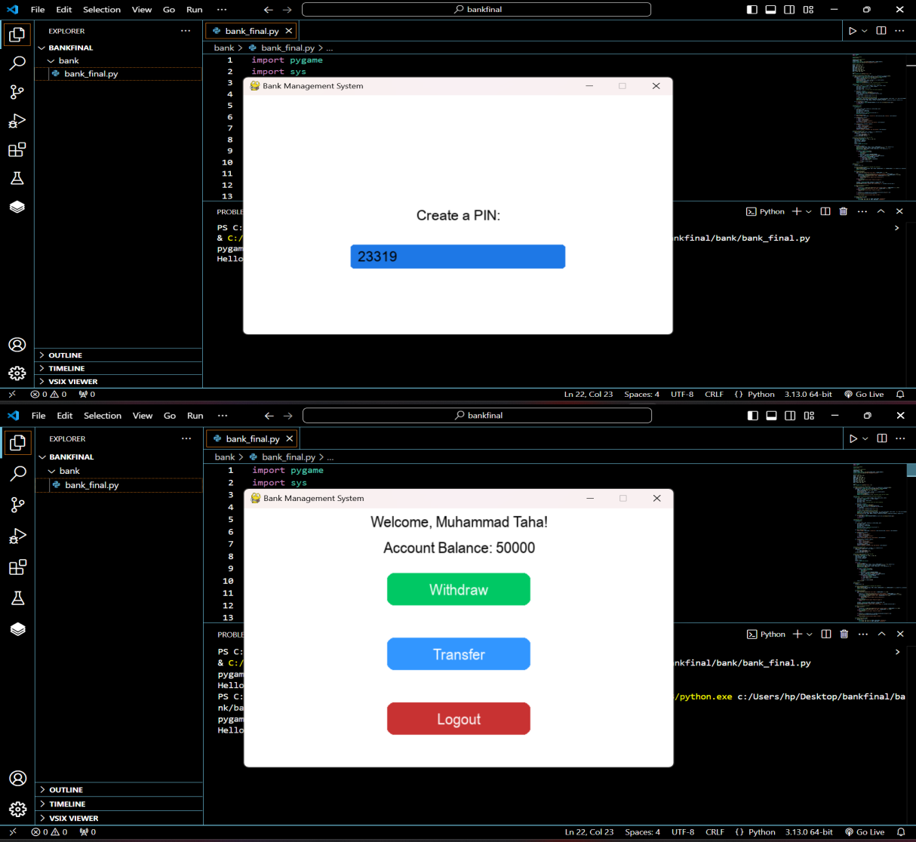

*Code Samples*

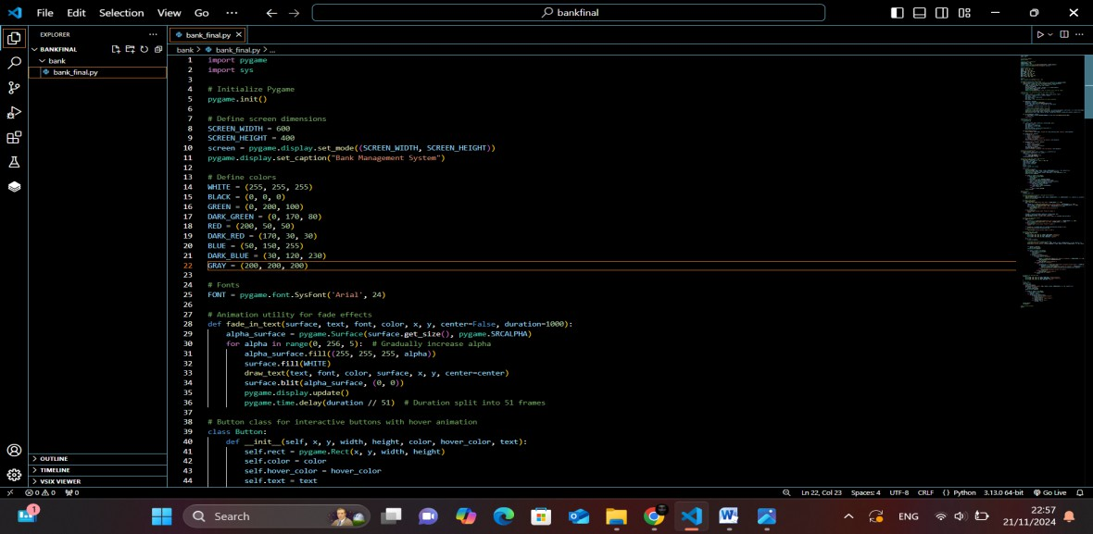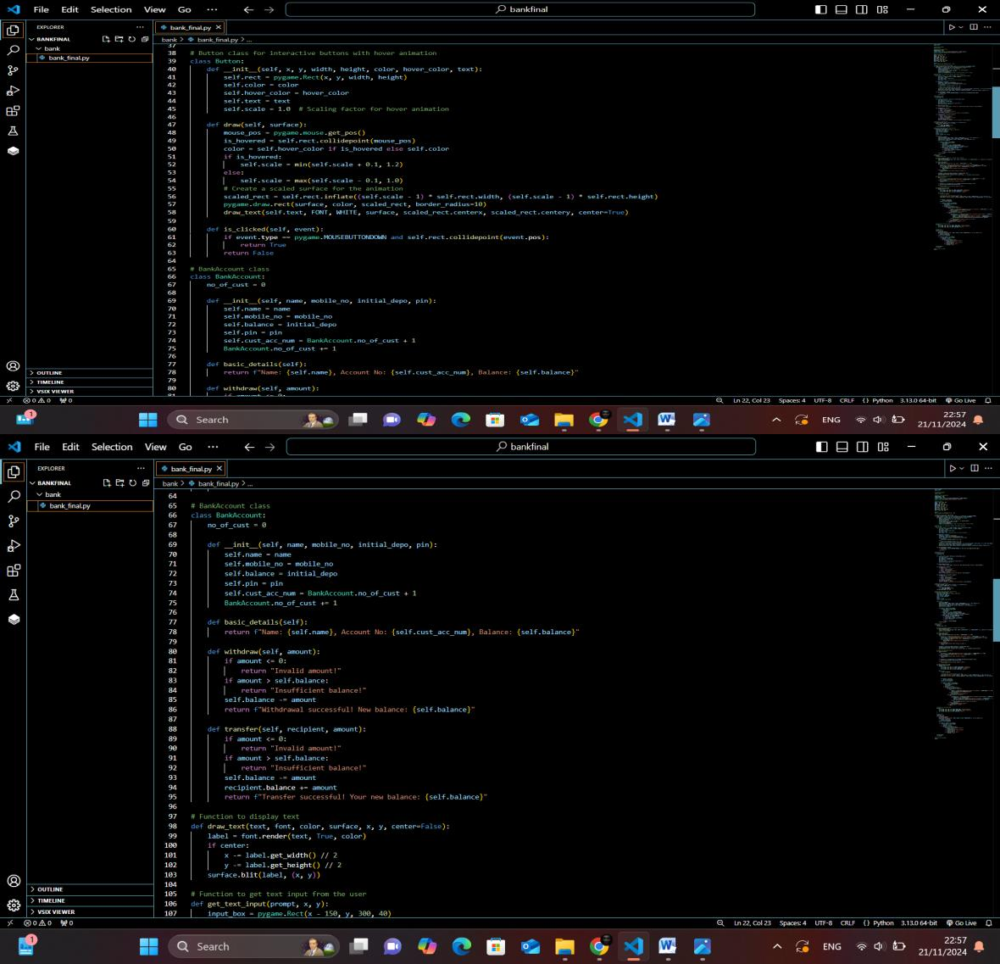

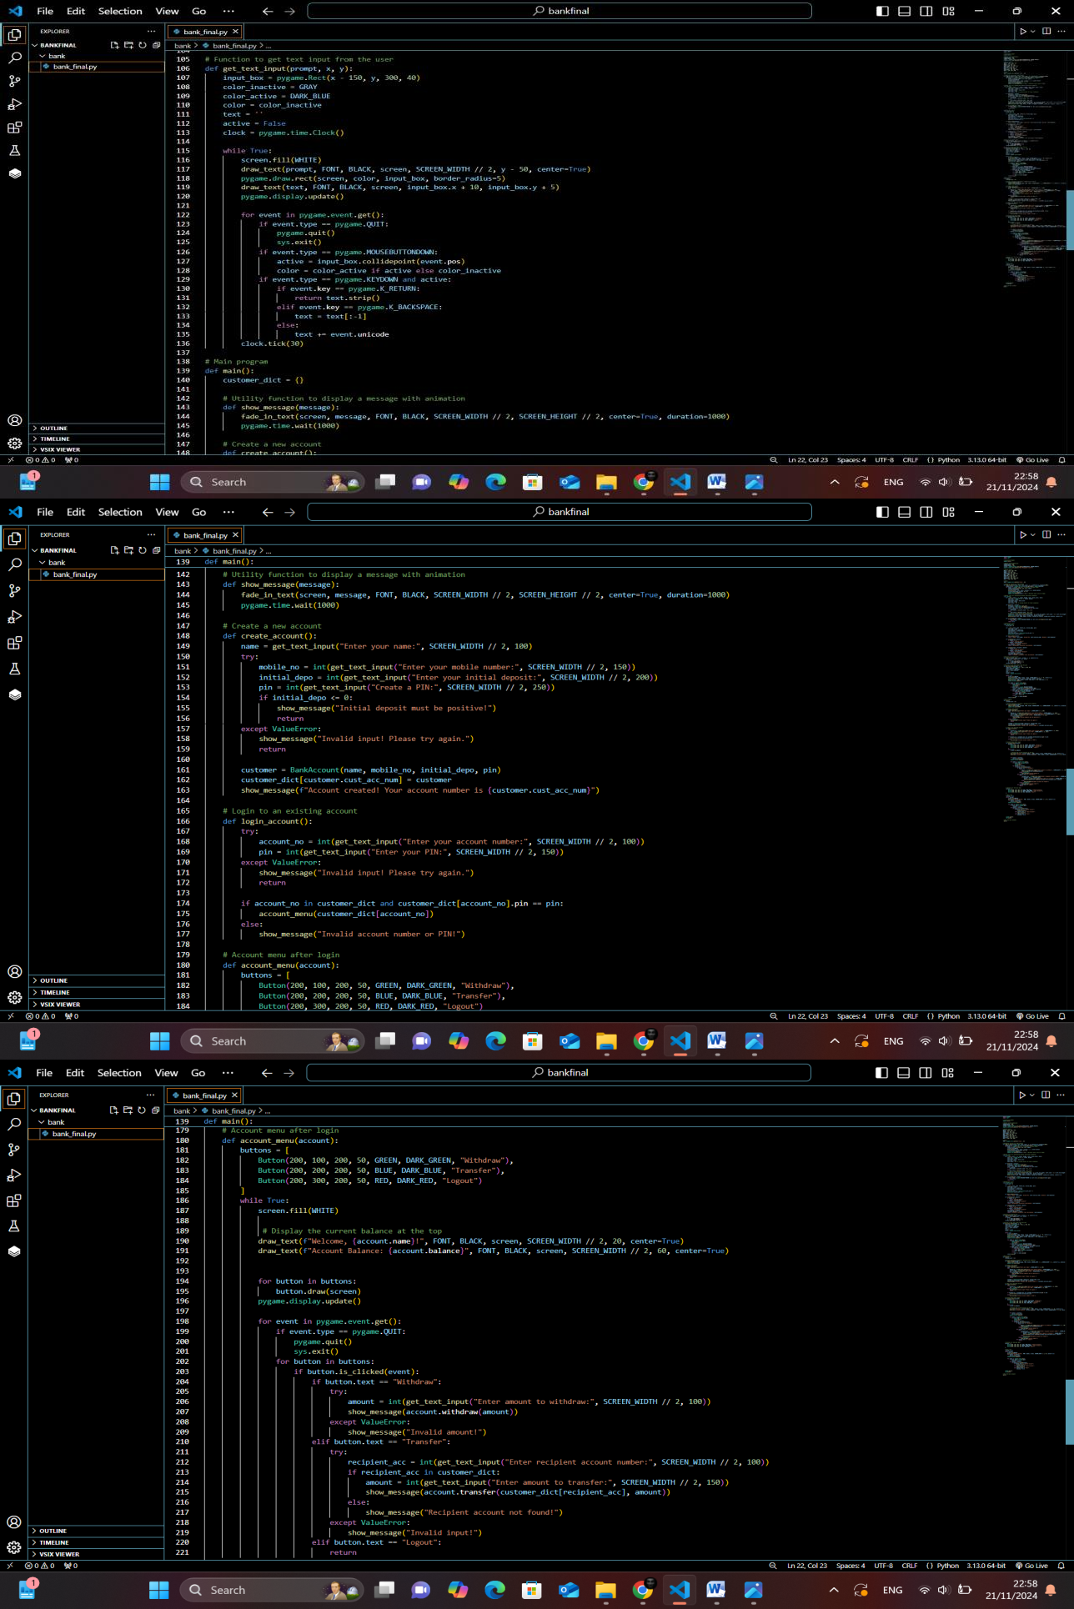

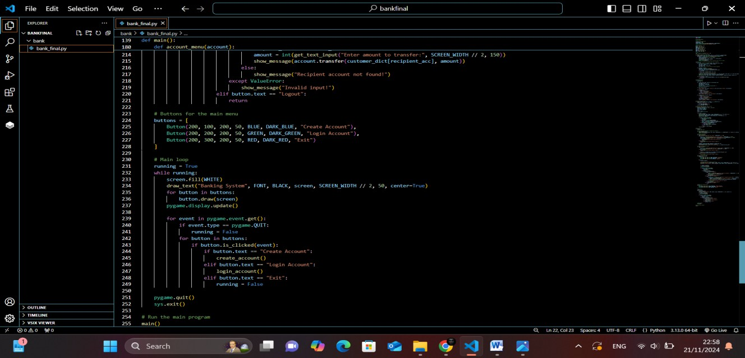

# 7. Conclusion

In conclusion, the PBL is a successful solution to the challenges in the IT industry. Our user-friendly module, powered by PYTHON, PY GAME LIBRARY, SYS LIBRARY and OBJECT ORIENTED PROGRAM

(OOP) creates a practical learning environment. We've designed it for users.

Thanks to our team's efforts and guidance from Sir Ali Baig, we've built a robust tool for IT professionals to apply their skills. Looking ahead, we're excited to enhance and expand that for the evolving needs of IT education. This project not only solves a problem but also boosts our confidence to tackle future challenges in the dynamic field of information technology.